


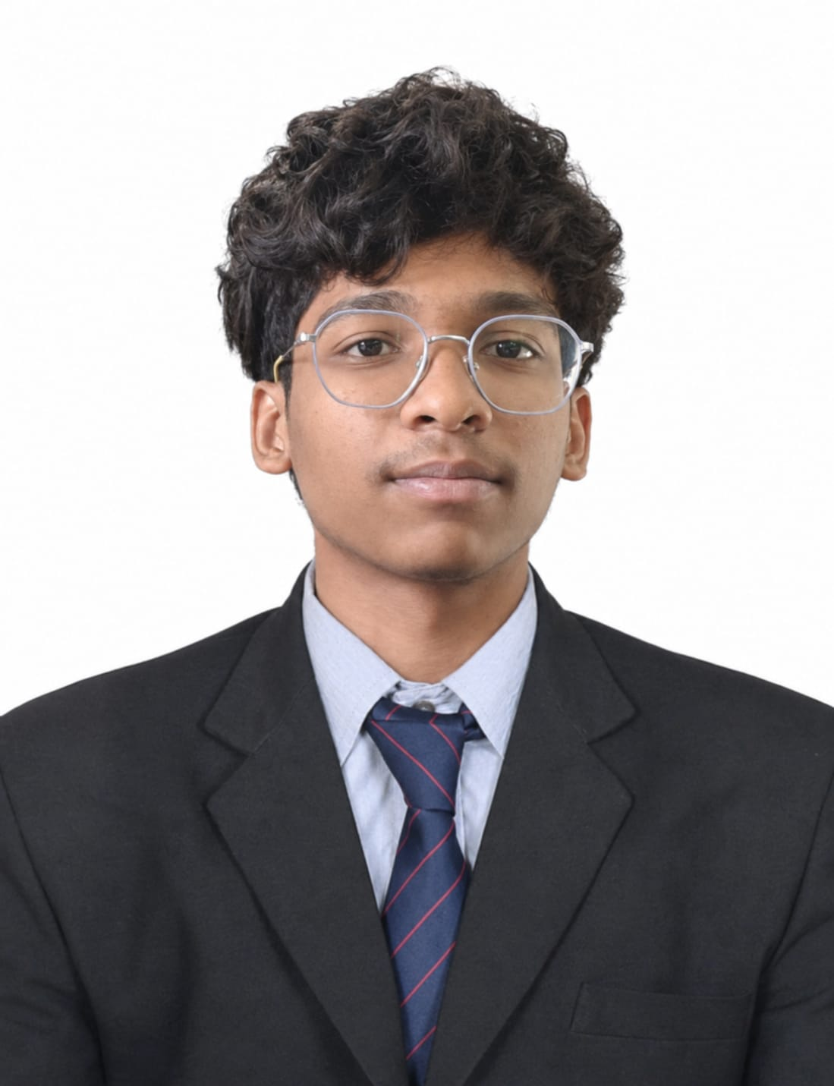

Education
Diploma in Computer science & Engineering
Hindustan Electronics Academy,

SSLC (10th)
HAL East High school,
State Board,
2024

Skills
- Coding
- SQL
- Debugging
- Microsoft Office
- Spreadsheets

+91 9606157090
suryaprakah224422@gmail.com
www.linkedin.com/in/hanish-p-b73b38437

Contact

HANISH P

CAREER OBJECTIVE

To begin my career in a reputed organization where I can apply my skills and knowledge gained during my diploma and grow professionally.

TECHNICAL SKILLS
- Basic knowledge of Software Tools
- Knowledge of Computer Network, Computer Hardware & Maintenance Application
- MS Office Word, Excel, PowerPoint
- HTML

CERTIFICATIONS
- MySql
- CyberSecurity

EXTRA-CURRICULAR ACTIVITIES
- Member of IIC(Innovative Institution Council)

PERSONAL PROFILE
- Father Name: Prakash B K
- Date of Birth: 13th of January 2009
- Gender: Male
- Language known: English, Kannada, Hindi, Telugu
- Nationality: Indian
- Hobbies: Cricket, Animation, Drawing
DECLARATION
I hereby declare that the above-mentioned information is true and correct to the
best of my knowledge and belief.
Date: 09/09/2026 Signature
Place: Bangalore Hanish P

